1. Autoclave: **All American Autoclave Electric 75X, Vol 39 Liter (Catalog No. OAA75X240)**

**Harga: Rp 17.000.000 (exclude PPn 10%)**

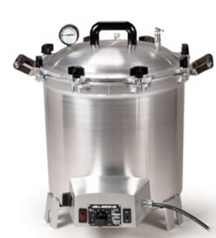

The All American Electric Sterilizer 75X-240V features:

* Suitable for dental, medical, veterinary facilities, laboratories and health and cosmetic applications
* Calrod immersion 1650 watt heating element , 50% faster startup than 25X
* 36% greater heating capability compared to 25X
* 64% greater capacity compared to 25X
* Crafted of the finest hand cast aluminum that resists aging and corrosion
* Stay-cool bakelite top handles and wing nuts
* Removable aluminum inner container with rack
* Interior stainless steel support stand
* More accurate TPI thermocouple, snapswitch and pilot light
* Portable, economical, reliable operation
* Pressure gauge conforms to the pressure gauge standard ANSI B40-1-1980
* Flexible metal exhaust tube
* 60 minute mechanical timer

**Sterilizer**  
240 Volt, 50/60 Hz   
1650 watts/6.88 amps  
Capacity - 41 1/2 Quarts (Liquid)  
Overall Height - 19 inches  
Bottom Height - 14 1/4 inches  
Inside Diameter - 15 1/4 inches  
**Inner Container**Inside Depth - 10 1/4 inches  
Inside Diameter - 14 inches  
Circumference - 44 1/2 inches  
Capacity - 27 Quarts  
Made in the U.S.A.  
1 Year Limited Manufacturer's Warranty  
Underwriters Laboratories Listed

2. **Incu-Shaker™ Mini with non-slip rubber mat, AC input 230 V, Schuko plug (Cat. Z763551-1EA)** Harga: Rp.51.000.000 (exclude PPn 10%)

**Optional MAGic Clamp™ Accessories:**

- MAGic Clamp magnetic clamp, 250 mL Erlenmeyer (Cat. Z763500-1EA)

@. Rp. 543.000 x 6 = 3.258.000

- MAGic Clamp magnetic clamp, 500 mL Erlenmeyer (Cat. Z763519-1EA)

@. Rp. 565.000 x 4 = 2.260.000

* MAGic Clamp Tube Rack, 32x15ml tubes (Cat. Z764647-1EA)

@. Rp. 3.100.000 x 1 = 3.100.000

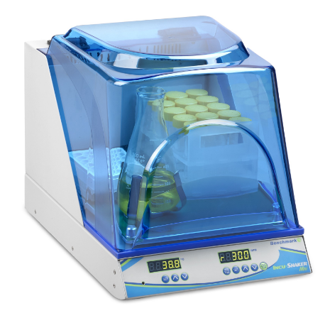

|  |  |
| --- | --- |
| **Speed:** | Variable, 30 to 300 rpm |
| Orbit: | 19mm / 3/4 in. |
| Temp. Range: | Ambient +5 to 60°C |
| Temp. Increment: | 0.1°C |
| Temp. Accuracy: | +/- 0.1°C |
| Temp. Uniformity: | +/- 0.25°C |
| Speed Increment: | 1 rpm) |
| Platform Dimensions: | 9.5 x 11.5 in./ 23.5 x 29 cm |
| Operating Temp. Range | +4 to +65°C |
| Dimensions:  (w x d x h) | 11 x 15.7 x 10.8 in. / 28 x 40x 27 cm |
| Weight: | 25 lbs (11.5kg) |
| Height, Lid Open: | 25 in. / 63 cm |
| Timer: | 1 min. to 48 hours / continuous |
| Electrical: | 230V, 50-60Hz, 300W |
| Warranty: | 2 Years |

3. Mikroskop Trinokular AmScope T360C dengan Kamera Digital 5MP (Kode: AMT360C5MP) Suplier: JavaIndotech. **Harga: Rp 15.057.500**

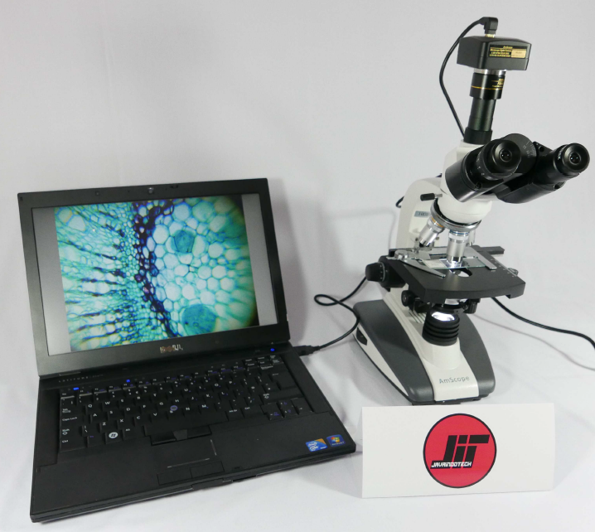

**Spesifikasi Mikroskop Trinokular AmScope T360C:**

◦ Nosepiece: quadruple

◦ Head: 30 degree inclined compensation free trinocular head

◦ Interpupillary Distance: 2-3/16″ – 3-0″ (55 – 75mm)\

◦ Wide-field Eyepieces: WF10X & WF25X

◦ Achromatic Objectives: 4X, 10X, 40X (spring), 100X (spring,oil)

◦ Stage Dimensions: 5-1/8″x 4-3/4″ (130x120mm)

◦ Stage Traveling Range: 2-3/8″x1-3/16″ (60x30mm)

◦ Coarse Focusing Range: 0-5/8″ (15mm)

◦ Abbe Condenser: NA=1.25 with iris diaphragm & filter

◦ Condenser Focusing: spiral control

◦ Illumination: variable 1W LED, 110V-6V/20W

◦ Filter: blue

◦ Accessories: Eye-guards, dust cover, immersion oil

**Spesifikasi Kamera Mikroskop Trinokular AmScope**

**T360C:**

◦ Sensor: Aptina MT9P001 CMOS (color)

◦ Sensor Size: 1/2.5″ (5.70mm(H) x 4.28mm(V), diagonal 7.13mm)

◦ Resolution: 2592×1944 (approx.5,040,000 pixels)

◦ Reduction Lens: 0.5X

◦ Pixel Size: 2.2μm x 2.2μm

◦ G Sensitivity: 0.53v / lux-sec (550nm)

◦ Frame Rate: 60fps @640×480, 18fps @1280×960, 5fps @2592×1944

◦ Exposure: 0.21~2000ms, ROI Auto & Manual

◦ Scan Mode: Progressive

◦ Dynamic Range: 66.5dB

◦ A/D Converter: 12-bit Parallel, 8-bit R.G.B to computer

◦ SN Ratio: 40.5dB

◦ Spectral Range: 380-650nm (with IR-filter)

◦ Binning: 1×1, 2×2, 4×4

◦ White balance: ROI White Balance/ Manual Temp-Tint Adjustment

◦ Color Rendering Technique: Ultra Fine Color Engine

◦ Capture/Control API: Native C/C++, C#, Directshow, Twain, Labview

◦ Recording System: Still Picture and Movie

◦ Cooling System: Natural

◦ Operating Temperature: -10°C~50°C

◦ Storage Temperature: -20°C~60°C

◦ Operating Humidity: 30~80%RH

◦ Storage Humidity: 10~60%RH

◦ Power Supply: DC 5V over USB Port

**Fitur Perangkat Lunak Kamera Mikroskop Trinokular**

**AmScope T360C:**

◦ Operating System: Windows XP/Vista/7/8/10 (32 & 64 bit), Mac OS X, Linux

◦ PC Requirements: CPU equals to Intel Core2 2.8GHz or higher, Memory: 2GB or more, USB2.0 port

◦ Advanced software for Window